

NATIONAL DIPLOMA: CUSTOMER MANAGEMENT
ID 20908 LEVEL 5 – CREDITS 243
LEARNER GUIDE
SAQA:10053
MANAGE CUSTOMER REQUIREMENTS AND NEEDS AND IMPLEMENT ACTION PLANS

Learner Information:
Details | Please Complete this Section
Name & Surname:
Organisation:
Unit/Dept:
Facilitator Name:
Date Started:
Date of Completion:

Copyright
All rights reserved. The copyright of this document, its previous editions and any annexures thereto, is protected and expressly reserved. No part of this document may be reproduced, stored in a retrievable system, or transmitted, in any form or by any means, electronic, mechanical, photocopying, recording or otherwise without the prior permission.

Key to Icons
The following icons may be used in this Learner Guide to indicate specific functions:
  Books | This icon means that other books are available for further information on a particular topic/subject.
  References | This icon refers to any examples, handouts, checklists, etc…
  Important | This icon represents important information related to a specific topic or section of the guide.
  Activities | This icon helps you to be prepared for the learning to follow or assist you to demonstrate understanding of module content. Shows transference of knowledge and skill.
  Exercises | This icon represents any exercise to be completed on a specific topic at home by you or in a group.
  Tasks/Projects | An important aspect of the assessment process is proof of competence. This can be achieved by observation or a portfolio of evidence should be submitted in this regard.
  Workplace Activities | An important aspect of learning is through workplace experience. Activities with this icon can only be completed once a learner is in the workplace
  Tips | This icon indicates practical tips you can adopt in the future.
  Notes | This icon represents important notes you must remember as part of the learning process.

NOTIONAL HOURS BREAKDOWN
The candidate undertaking this unit standard is best advised to at least spend eighty hours of study time on this learning programme. Below is a table which demonstrates how these eighty hours could be spread:
TIMEFRAME
Total Notional Hours | Contact Time | Non contact-  Self-Study/Assessment
Credits (8) x 10 = 80 | 24 HRS | 56 HRS

1. | Learning Programme Name: |  |  | REFER TO COVER PAGE
2. | SAQA Qualification/Unit Standard Title: |  |  | REFER TO COVER PAGE
3. | Qualification/ |  | 4. | SAQA ID Number | 10053 | 5. | NQF Level | 5 | 6. | Credits | 6
3. | Unit Standard
7. | PURPOSE for offering this programme to your learners: |  |  | REFER TO NEXT PAGE
8. | TARGET AUDIENCE for this specific programme: |  |  | REFER TO NEXT PAGE
9. | Entry/Admission Requirements: |  |  | REFER TO NEXT PAGE
10. | Timeframe for Training:  (Total Hours/Days/Weeks) |  |  | Theory content –Role play, Simulation, Group work, Pair work = 18hrs.  Non contact session- self-study, assignment, practise guided by coach or mentor, formative assessment and summative assessment = 56 hrs.

Learner Guide Introduction

About the Learner Guide… | This Learner Guide provides a comprehensive overview of the Manage customer requirements and needs and implement action plans ,and forms part of a series of Learner Guides that have been developed for series of Learner Guides are conceptualized in modular’s format and developed They are designed to improve the skills and knowledge of learners, and thus enabling them to effectively and efficiently complete specific tasks. Learners are required to attend training workshops as a group or as specified by their organization. These workshops are presented in modules, and conducted by a qualified facilitator.
Purpose | The purpose of this Unit Standard is to Manage customer requirements and needs and implement action plans
Outcomes | Manage customer requirements and needs and implement action plans
Assessment Criteria | The only way to establish whether a learner is competent and has accomplished the specific outcomes is through an assessment process. Assessment involves collecting and interpreting evidence about the learner’s ability to perform a task.This guide may include assessments in the form of activities, assignments, tasks or projects, as well as workplace practical tasks. Learners are required to perform tasks on the job to collect enough and appropriate evidence for their portfolio of evidence, proof signed by their supervisor that the tasks were performed successfully.
To qualify | To qualify and receive credits towards the learning programme, a registered assessor will conduct an evaluation and assessment of the learner’s portfolio of evidence and competency
Range of Learning | This describes the situation and circumstance in which competence must be demonstrated and the parameters in which learners operate
Responsibility | The responsibility of learning rest with the learner, so:  - Be proactive and ask questions,  - Seek assistance and help from your facilitators, if required.

Learning Unit1
UNIT STANDARD NUMBER : 10053
Manage customer requirements and needs and implement action plans
LEVEL ON THE NQF : 5
CREDITS : 6
FIELD : Business, Commerce and Management Studies
SUB FIELD : Marketing

PURPOSE: | This unit standard is a core standard and forms part of the qualification, National Diploma, and is registered at Level 5 on the National Qualifications Framework (NQF). Learners working towards this standard will be learning towards the full qualification, or will be working within a Marketing Environment, specialising in either Marketing Communication, Marketing Management, Market Research or Customer Management, where the acquisition of competence against this standard will add value to one`s job.  This standard will also add value to learners who are starting their own business and recognises that Marketing forms an integral component of any business.  The qualifying learner is capable of:  - Listening to and interpreting customer needs  - Describing action plans  - Implementing action plan to meet customers’ needs  - Tracking and measuring the action plan to its completion
LEARNING ASSUMED TO BE IN PLACE:
• Learners accessing this qualification will have demonstrated competence against the standards in the National Certificate in Marketing, Marketing Communication or Marketing Research or marketing Management or Customer Management or equivalent at NQF Level

SESSION 1.
Listen to and interpret customer needs

Learning Outcomes
- Questioning skills are used to obtain information so interpretation of customer's needs is accurate.
- Customers’ needs are prioritised.
- Customer is listened to, using established methods.

Questioning skills are used to obtain information so interpretation of customer's needs is accurate.

There are two types of questions (open and closed) and both have their advantages and disadvantages. Getting the balance right between open and closed questions can make dialogue much easier and consequently the flow of information is more readily exchanged.

Closed Questions
These questions require a client to answer yes or no. Closed questions can be used to control a dialogue. They can even be used to pre-condition a person into saying yes. Ask three closed questions one after the other where the answer is yes and the likelihood of the fourth answer to a question being yes is significantly increased since a habit of responding yes has been formed. The same applies if the response is no. Three closed questions with a no response means that subsequent closed questions are likely to be met with a no.
Whilst closed questions can be used to ascertain positive and negative responses and even hone in on specifics, closed questions do not encourage a client to open up and conversation can often be short, sweet and awkward. Closed questions begin with phrases such as;
• Are you?
• Do you?
• Could you?
• Would you?
• Will you?
• Can you?
Open Questions
Open questions simply encourage the client to open up and provide information relevant to the discussion. They can also help develop a feeling of mutual interest and trust. Open questions should be designed to help you gather information that will enable you to offer a solution to a customer need. Open questions should enable you to find out what products or services the customer currently uses and how he or she feels about them.
Open questions begin with;
• Who?
• What?
•Where?
•Why?
• When?
•Which?
• How?
Open questions can be preceded with the TELL ME phrase. Tell me who? Tell mewhen? Tell me how? Tell me why? Etc. This is a personal choice and should only be used when you feel the other person would be comfortable with such a lead. It can be deemed as an instruction and used inappropriately can lead to the other party clamming up and providing little or no information
Tactical and Strategic Open Questions
There are two distinct types of open questions:
Tactical Open Questions give you data
• What is your customer ref number?
• How many employees are there?
• What is your telephone number and address?
• What type of process do you use?
• How often do you tender?
Tactical open questions are excellent in gaining information that you might need at a later stage to prepare a clear and specific proposal.
For example;
Which airport do you want to fly from?
What dates for travel do you have in mind?
How many people will be travelling?
What level of budget are you looking to spend?
Strategic Open Questions tell you how the other party feels and reveals their buying motives.
• What is the reason?
• Why did you buy?
• What do you think?
• What would it mean to you if?
• How important is it to you that?
Asking strategic questions can be very powerful. This is where the real value is to be found. However strategic open questions can be felt intrusive and therefore requires an element of trust and empathy to be exhibited by the questioner. However, if one can master the skills of asking strategic open questions, one should be able to build trust and rapport with client’s enabling good value judgements to be made.



Prioritising to Meet Customer Needs

Prioritise needs
As part of researching your customer's needs, you or your company may have obtained feedback on your performance in meeting those needs.

You may now see that there is a difference between what you believe is important to the customer and how you believe the company is meeting the customer's priorities.

If there is a difference between the customer's expectations and company performance, then you will need to decide what action to take, consistent with the needs of the business.
First, list all of the service gaps that have been identified

If your service performance is above the customer's expectations, consider whether this over servicing delivers value in other ways (for example, better than expected response times may be maintained for efficiency rather than customer service reasons), or whether you have the opportunity to utilise resources better by directing them to areas where there is under servicing

Identify the causes for perceived poor performance in the areas identified, keeping in mind that there are likely to be several causes in each case

Consider whether two strategies are needed; one to address improvements across the company or department, and another to address specific service improvements for specific areas or customer groups

Prioritise the service improvement opportunities and select those actions that are most suitable for you to take
The 7 Best Ways to Gather Customer Feedback


Successfully utilizing customer feedback is a must for any business looking to navigate the treacherous waters of today’s business world.
Feedback can help guide your decision-making and point out subtle tweaks that may benefit your product. It’s also essential for satisfaction among your current customers.
Getting a handle on how customers view your product, support and brand is invaluable, so today we’re going to look at the best ways you can gather insights from the current and prospective customers who visit your site.

1. Email/Contact Forms
There is no question that email is one of the most valuable ways to gather candid customer feedback.
However, there are a few ways you can improve the way customers reach out to you via email to maximize this channel’s effectiveness ... and all of these changes will create a better experience for customers, as well!
2. Surveys
Crafting a useful customer survey is no easy task. There are so many potential questions you could be asking customers, but you have to be careful in your approach.
One way the web has made collecting surveys easier is to let you test a longer, more traditional survey versus a shorter, “slider” survey that appears onscreen as a customer browses your site
3. Usability Tests
Usability testing requires more upfront planning, but far and away delivers more insights than any of the methods listed here. It uncovers things customers sometimes don’t even know they are thinking about or struggling with, and usually provides you with a clear path to make the experience better.
At Help Scout, we regularly turn to usability testing to get the design details for a specific process or feature just right. It may be 90% finished, but well-run tests guarantee that we get the final (most important) 10% right. We’ve been working for months on a new feature that will launch in the coming weeks, and did extensive usability testing with customers in order to get the details perfect. It went so well that we re-designed the whole thing to better align with customer expectations.

4. Exploratory Interviews
Can direct outreach really be beneficial in getting feedback from customers?
Absolutely—especially when you conduct it the right way Truly understanding your customers is often as easy as talking to them directly.
This direct outreach can also help fill in the gaps that less personal forms of feedback tend to create. For instance, as Lars Lofgren highlights in this article, if you provide an app that creates invoices, and customers have repeatedly told you that they want to customize the design, a few things could be going on here:
- Your customers are mostly designers, and this customization aspect is important for branding.
- Your current design options just plain suck.
- They really only need to tweak a few minor sections.

5. Social Listening
Listening through social media can prove particularly useful for gathering candid feedback from customers. I refer to this method as “social listening” because direct comments or mentions on social networks aren’t the only way for your business to get responses.
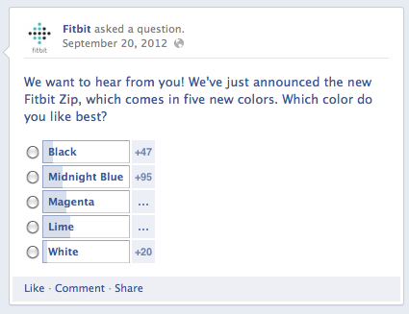
Consider this quick poll conducted on Facebook:

In this instance, a short poll on a highly popular social network makes plenty of sense; it’s too short to include as a separate survey, and asking this question on-site would distract from far more important goals.

6. On-Site Activity (via Analytics)
What are your users telling you without telling you?
Sometimes the best feedback is found when users are candidly using your product (and not being asked how they use it). To get a peek at these sorts of insights, you should turn to analytics that showcase how users are interacting with your site.
For example, let’s say you are using content as a form of customer service. You might see that thousands of people are visiting your content to get their questions answered ... but have you looked at how they are using it?
If your FAQs section has a 0:09 average on-page times and an awful bounce rate, you know something is not being communicated clearly. People are visiting your support content but obviously not utilizing it.
7. Comment Boxes
Speaking of KISSmetrics, one of the more creative ways we’ve seen for measuring user satisfaction with a particular page can be found in how they implement feedback boxes at the bottom of particular pages.

SESSION 2.
Describe action plan

Learning Outcomes
- Action plan is agreed with all stakeholders.
- Resources required to implement the action plan are communicated.
- Action plan is evaluated in terms of its ability to meet customer requirements.

Action Plans
Small Scale Planning

Simple projects can be completed with simple plans.

Whether it's sending out an email newsletter, putting together a presentation for senior managers, or working on a special request for a client, many of us have to complete simple projects as part of our day-to-day responsibilities.
These small- to medium-sized projects may, at first glance, not seem to need much thought.
But, occasionally, we can overlook a key step or "to do" item that can derail all our efforts.
For instance, how do you make sure that you've covered everything? Are there any actions that need to be taken early on in the project for it to succeed? And are you clear about when you need to do key tasks, in what sequence, to meet your deadline?
Action Plans are simple lists of all of the tasks that you need to finish to meet an objective. They differ from To-Do Lists in that they focus on the achievement of a single goal.
Action Plans are useful, because they give you a framework for thinking about how you'll complete a project efficiently. They help you finish activities in a sensible order, and they help you ensure that you don't miss any key steps. Also, because you can see each task laid out, you can quickly decide which tasks you'll delegate or outsource, and which tasks you may be able to ignore.
Using Action Plans
Use an Action Plan whenever you need to plan a small project.
To draw up an Action Plan, simply list the tasks that you need to carry out to achieve your objective, in the order that you need to complete them. (This is very simple, but it is still very useful!)
Use the three-step process below to help you:
Step 1: Identify Tasks
Start by brainstorming all of the tasks that you need to complete to accomplish your objective.
It's helpful to start this process at the very beginning. What's the very first action you'll need to take? Once that task is complete, what comes next? Are there any steps that should be prioritized to meet specific deadlines, or because of limits on other people's availability?
Step 2: Analyze and Delegate Tasks
Now that you can see the entire project from beginning to end, look at each task in greater detail.
Are there any steps that you could drop, but still meet your objective? Which tasks could you delegate to someone else on your team, or could be dealt with by a freelancer? Are there any deadlines for specific steps? Do you need to arrange additional resources?
Step 3: Double-Check with SCHEMES
Use the SCHEMES mnemonic to check that your plan is comprehensive.
SCHEMES stands for:
- Space.
- Cash.
- Helpers/People.
- Equipment.
- Materials.
- Expertise.
- Systems.
You may not need to think about all of these to complete your project. For instance, for a small internal project to streamline the format of your team's reports, you might only need to think about "Helpers/People," "Expertise," and "Systems."
Note:
Once you've completed your Action Plan, keep it by you as you carry out the work, and update it with additional activities if required.
Learning from Your Action Plan
If you think you'll be trying to achieve a similar goal again, revise your Action Plan after the work is complete, by making a note of anything that you could have done better.
For instance, perhaps you could have avoided a last-minute panic if you'd alerted a supplier in advance about the size of order you'd be placing. Or maybe you didn't allow enough time to do certain tasks.
Tip:
If you'll be doing similar work again, consider turning your Action Plan into an Aide Memoire . This is a checklist that you progressively refine and improve to make sure that you remember to do everything important for success.
Managing Bigger Projects
Action Plans are useful for small projects, where deadlines are not particularly important or strenuous, and where you don't need to co-ordinate other people.
As your projects grow, however, you'll need to develop more formal project management skills, particularly if you're responsible for scheduling other people's time, or need to complete projects to tight deadlines.

Tip:
Visit the Mind Tools Project Management section to develop your project management skills. In particular, see our article on Gantt Charts , and take our How Good are Your Project Management Skills test.
Our Bite-Sized Training session on Planning Small Projects also teaches some useful project planning techniques.
You can also use Action Plans in conjunction with your To-Do Lists , or Action Programs .
Action Programs are "heavy duty" versions of To-Do Lists, which help you manage many simultaneous small projects. This is something that managers at all levels need to do routinely.
Key Points
An Action Plan is a list of tasks that you need to do to complete a simple project or objective.
To draw up an Action Plan, simply list the tasks that you need to complete to deliver your project or objective, in the order that you need to complete them.
To do this, first brainstorm every step you'll need to take to follow your task to completion. Then, analyze tasks to see if there are any that can be pruned, or delegated. Lastly, use the SCHEMES mnemonic to double check that you've considered all critical areas.
If you need to schedule people's time, or meet tight deadlines as part of your project, consider using the other project management techniques mentioned.

SESSION 3.
Implement action plan to meet customers’ needs

Learning Outcomes
- Actions of frontline providers are evaluated against action plan agreed previously.
- Action plan is implemented within agreed timeframes, budgets and resource allocations.
- Action plan is implemented to the satisfaction of the customer and the organisation.
- Documentation relating to the action plan is complete, concise and in the required format and location.

Lead a customer focus program from the top. Take a strategic decision at board level to commit the organization to customer focus. According to training consultancy The Customer Focus, "the fundamental purpose of a business is to satisfy customer/client needs at a profit." Allocate resources to communicate the importance of customer focus to employees and implement training programs across the organization. Set a vision for the organization to become the leader in providing quality service.

Identify the departments that have most impact on customer satisfaction levels. Help different departments understand their role. Prioritize employees and departments that may not see their jobs as customer-focused, such as invoice clerks, delivery drivers, maintenance engineers, telephone receptionists, warehouse staff and development engineers. According to Customer Forum, it is employees and their behavior that create a competitive differentiator.

Appoint customer focus champions to communicate with employees and translate the overall vision to departmental objectives. Explain to employees the problems customers encounter in dealing with individual departments. Use examples of poor service to illustrate problems customers face. If possible, circulate comments or complaints from customers about standards of service.

Ask the champions to work with departments to establish measurable action plans to improve customer focus. An action plan for the accounts department might include understanding the problems the customers have with invoices, improving the accuracy and timing of invoices and responding to customers' invoice queries within two working days.
Set customers focus standards for each department and implement a reporting mechanism to monitor progress against standards. Identify training requirements and business process changes that will enable departments to improve performance and meet the customer focus standards. Introduce reward and recognition programs to motivate individual employees and departments to improve their performance. Communicate successes throughout the organization and publish examples of the best practice or tips for improving customer focus.

Hold regular review meetings with champions and departmental managers to ensure that the customer focus program continues to meet its objectives. Assess feedback from customers to see whether you need to implement further changes. Use a standard such as ISO 9001:2000 that makes customers the focal point of a process-based quality management scheme. ISO 9000:2000 requires an organization to monitor information relating to customer perception to establish whether it has met customers' requirements.

SESSION 4.
Track and measure the action plan to its completion

Learning Outcomes
- All stakeholders agree measurement techniques.
- Actual progress is evaluated and reviewed against the action plan agreed.
- Identified variances against action plan are recorded and reasons for the discrepancy are found and analysed.
- Measurement report and review records are complete, concise, completed in the required format and within the agreed time frame.

Why should we measure customer satisfaction and who should be involved?

The experience that customers have of services can be explored in various ways.
Qualitative research techniques can be used to better understand a service through the customers’ eyes, and to explore in depth their experiences and expectations. Quantitative research can provide numerical measures of customer satisfaction and statistically representative findings to assess the performance of a service and provide information to drive improved service quality. This is referred to as Customer Satisfaction
Measurement and is our focus here.

Customer satisfaction measurement involves the collection of data that provides information about how satisfied or dissatisfied customers are with a service. As well as providing an organisation with ‘scores’, the data can be used to understand the reasons for the level of satisfaction that has been recorded. This information can be collected and analysed in many different ways. This toolkit explores the basic processes and the relative benefits of different approaches.
Customer satisfaction measurement is a questionnaire-based research approach.
However, for quantitative measurement to be effective, it will generally need to be preceded by qualitative research to explore the key features of a service from the perspective of the customer. Customer Journey Mapping and other techniques that do this are discussed in detail in the CIF publication on this subject.

Why should we measure satisfaction?

While good research can be used for performance management and/or to meet statutory requirements, the most successful customer measurement programmes are motivated by the desire to put customer focus at the heart of an organisation.
Customer-focused organisations view customer satisfaction measurement as a means rather than an end – as part of a cycle of continuous improvement in service delivery, and as part of the wider toolkit of customer insight techniques. Many organisations regularly track their levels of customer satisfaction to monitor performance over time and measure the impact of service improvement activity.
Customer satisfaction measurement allows an organisation to understand the issues, or key drivers, that cause satisfaction or dissatisfaction with a service experience. When an organisation is able to understand how satisfied its customers are, and why, it can focus its time and resources more effectively.

Customer satisfaction measurement may also enable an organisation to understand the extent to which satisfaction with a service is influenced by factors outside of its control (such as the media) and to differentiate between what people say influences how satisfied they are, and what is really driving their satisfaction during a service experience. Customer satisfaction measurement can help an organisation understand what it can and cannot control.
Most importantly, customer satisfaction measurement helps an organisation focus on its customers, and should galvanize service owners, customer-facing staff, policy, strategy and research staff, as well as senior management, around the aim of improving the customer experience

Who should be involved?
The most important stakeholders in customer satisfaction measurement are, of course, the service customers themselves. From an internal perspective, however, there are a number of professional groups whose involvement in the research will ultimately determine whether or not it is effective. The customer measurement programme itself may be executed by the research community within an organisation, but for implementation to be effective it needs to be ‘owned’ by the organisation:
- Senior management can make the difference between good research that remains unused and genuine service transformation. The involvement of senior management not only signals that the work is viewed as strategically important, it also means that those who have the power to act on the findings are more likely to do so.

- Political leaders are important to help agree and articulate the policy commitments in terms of service improvement that can be undertaken as a result of the findings. In particular, the early involvement of politicians in recognising the need to improve customer experience can lead to more timely action on the findings of the research. This is particularly important in local government where the leadership tends to be more closely involved in service design and delivery.
- Policy and Strategic staff should use the findings to support strategic decision making.
- Research and Insight staff will need to analyse the data and share findings effectively.
- Communications staff should be involved in communicating the research findings and resulting actions to internal and external audiences, including customers.
- Operational management need to understand how the findings can be applied to their area of responsibility. Customer satisfaction measurement will give a sense – at a very tactical level - of how customers feel about the service they are providing and the performance of staff involved in delivery of the service. Service directors need to understand why they are obtaining these results and how they can be used to drive forward improvements in delivery.
- Customer-facing staff is incredibly valuable in customer research programmes for many reasons.
From their day to day work, customer-facing staff will have ideas about how customers view the experience of a service and the reasons why experiences are satisfactory or not. When preparing the way for customer research, it is important to tap into this insight as it can guide the focus of the work and provide valuable material for questionnaire development. Customer-facing staff is also critical stakeholders when it comes to implementing the results of customer satisfaction measurement: it will often be their job to deliver the changes which can bring improvements in the customer experience. Their commitment and buy-in is essential.

What will the process involve?

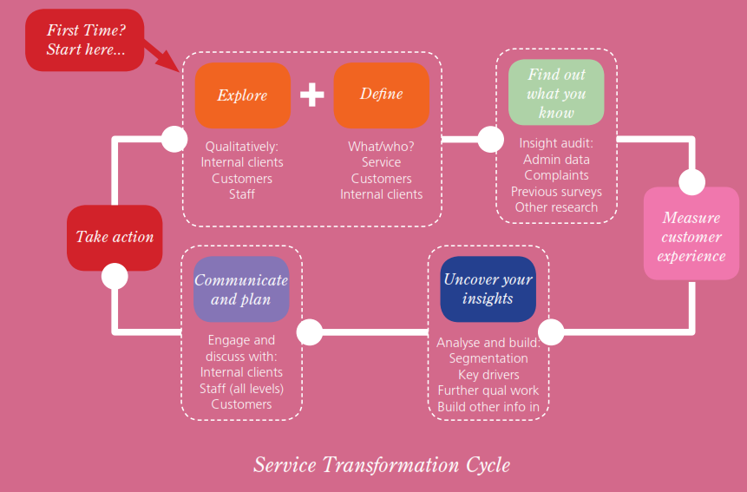
What will the process involve?
Once the survey has been conducted the data will need to be interpreted to provide actionable insights for the organisation. Finally, the results will need to be communicated across the organisation in such a way that the findings are taken on board and action taken as a result. For many organisations this process will form a continuous cycle of improvement.
For further guidance on embedding customer insight in your organisation, see the Customer Insight Forum’s paper establishing an Effective Customer Insight Capability in the Public Sector.

The Government Communication Network’s engage programme also provides an excellent framework for the effective use of customer insight, taking well tried principles of strategic communication and adapting them for Government to develop communications that shift attitudes and change behaviours.

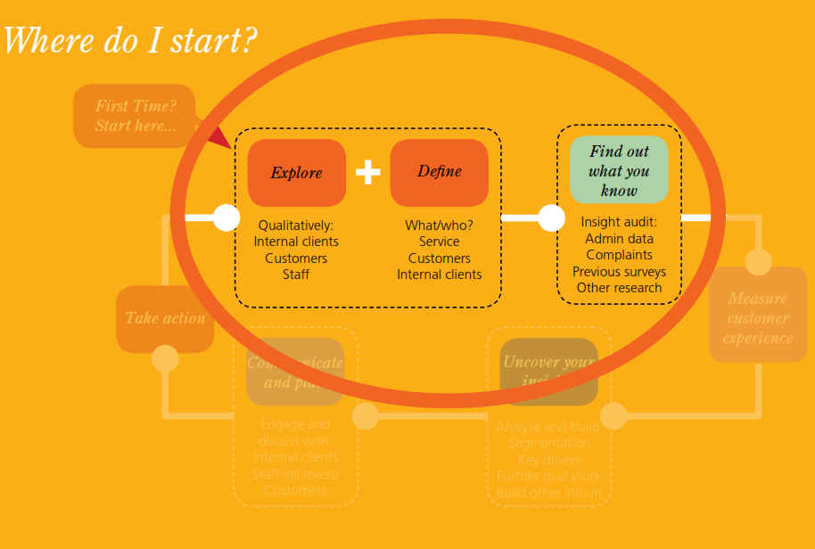
This section provides a check list of questions to answer before starting to measure customer satisfaction. All organisations, whether they are already carrying out customer satisfaction measurement or are relatively new to it, should consider these points to ensure that they are spending taxpayers’ money wisely.
Broadly speaking there are four questions to address, and we will go through each of these in turn in more detail:
- How do I define my service?
- Who are my customers?
- What do I know already?
- What else can I find out?
How do I define my service?
Defining the service that the organisation (or relevant part of it) provides will help inform everything else.
The most fundamental things that an organisation should consider are what its service is and what vision it has for it. Among the more specific issues to consider when measuring customer satisfaction are:
- How do customers come to use my service?
- Does my service involve an outcome that is likely to affect satisfaction?
- Do customers pay for my service or is it ‘free at the point of delivery’?
- Are my customers involved in simple or complex interactions with my service?
- How do customers interact with my service?
- Do customers define my service in the same way that I do?
The answers to these questions can influence both customer perceptions of the service and the way in which the customer satisfaction measurement programme is designed, conducted and analysed.
It is therefore important to think through these issues before designing or commissioning customer satisfaction measurement.
How do I measure satisfaction?
Once you have completed the preliminary stages described in Section 3, you can start to think about how satisfaction should be measured for your organisation.
There are three major decisions to be made:
- What should I ask?
- Who should I interview?
- How should I collect the information?

What should I ask?
The steps that you will already have taken to define your service and work out what you already know should have begun to shape your questionnaire.
The next step is to think more in detail about the questions you should ask.
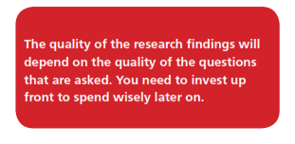

What types of question should be included?
There are four broad types of question that make up the majority of most customer satisfaction questionnaires.
● Overall rating measures
● Service-specific questions
● Customer priorities
● Customer characteristics
Overall rating measures
Overall rating measures are questions where customers are asked to rate various aspects of the service (e.g. telephone call handling, the application process etc) and their experience of the service as a whole.
These questions generally use a rating scale of one type or other to summarise the customer’s perceptions or feelings about a service or aspects of it. While there has been much debate within the research community about which scales work best in customer satisfaction measurement, there is no
& Understanding Customer Satisfaction provides a discussion of different approaches and includes example questionnaires based on these approaches.

Overall rating questions in public sector research typically use satisfaction or performance scales, such as those shown below.
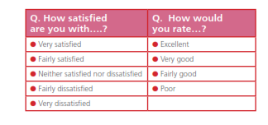
In the private sector, where choice and competition are more common, ‘likelihood to recommend’ scale is often used, as shown below, and has been found to discriminate between customers more effectively than satisfaction or performance scales.
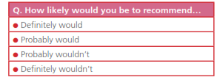
This measure would be appropriate for public sector services where the customer has a degree of choice in whether or not to use the service, for example, in relation to advice services, schools, educational courses, dentists, etc. Variations on this theme could be used for other services, for example, “would you tell other people that this service was easy or difficult to use?”
Service-specific measures
Overall rating measures provide a snapshot of how customers perceive the service as a whole and specific components of it, but do not explain why customers feel the way they do. While these measures might

